OPERATOR QUICK REFERENCE
Low Energy Test Bench
Clutch Endurance Testing Machine

Field | Details
Customer | Valeo Friction Materials India Private Limited
Machine | Low Energy Test Bench — Clutch Endurance Test
Location | R&D Building, R&D Cell, Chennai – 603 204
Document type | Operator Quick Reference (condensed from full Operating & Safety Manual)
Full manual reference | [Insert full manual document number]
Revision | 00
Date | March 2026
Prepared by | Independent Safety Consultant — B11 LMSS Certified
Classification | Confidential — Authorised Valeo personnel only

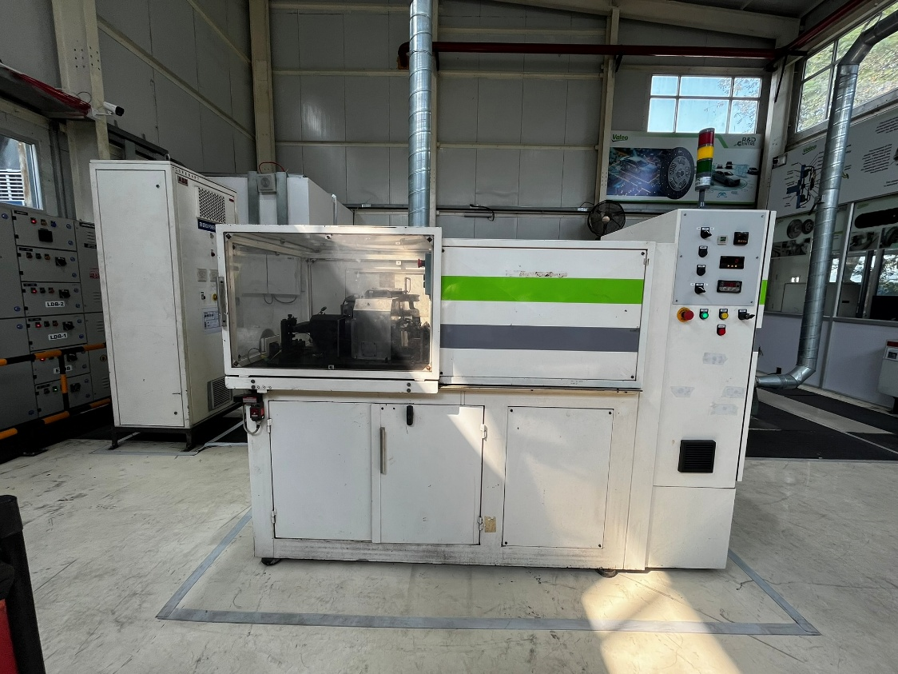
This document is a quick reference only. Always refer to the full Operating & Safety Manual for complete procedures, compliance detail, and legal requirements.

Table of Contents
Table of Contents 1
1 Machine Identification Summary 1
2 Control Panel — Button Quick Reference 1
2.1 Indicator lamp status 1
3 Pre-Start Verification Checklist 1
Pre-start sign-off 1
4 Operating Cycle — Step-by-Step Summary 1
4.1 Machine starting 1
4.2 Cover plate preparation (at oven — before loading) 1
4.3 Clutch assembly loading (Manual mode) 1
4.4 Clutch displacement setting 1
4.5 Test launch 1
4.6 Test monitoring — each shift 1
4.7 Inspection at 6,000 cycles 1
4.8 Clutch removal 1
4.9 Machine shutdown 1
5 Safety Rules and PPE 1
5.1 Non-negotiable safety rules 1
5.2 PPE requirements 1
5.3 Emergency stop procedure 1
5.4 LOTO — Lockout / Tagout Procedure 1
5.5 Thermal hazards 1
5.6 Dust hazard 1
6 Alarms and Troubleshooting — Quick Reference 1
7 Maintenance Schedule Summary 1
7.1 Air filter replacement summary 1
7.2 Calibration summary 1
8 Emergency Contacts 1
9 Open Actions Register — Summary 1

1 Machine Identification Summary
Field | Details
Machine name | Low Energy Test Bench — Clutch Endurance Test
Machine type | Automated endurance test bench
Manufacturer | Not available — retrofit machine (refer OA-001)
Serial / Model number | Not available — no nameplate (refer OA-001)
Control system | New Craft Technology — Job No. 1639, Rev R0, Dec 2025
Location | R&D Building, R&D Cell
Factory | Valeo Friction Materials India Pvt. Ltd., Chennai – 603 204
Main power supply | 415V AC, 3-phase, 50 Hz
Control voltage | 24V DC
Pneumatic supply | 4 to 6 bar (regulated)
Clamping force range | 450 to 500 DaN
Test management software | MORPHEE (Windows XP workstation)
Test creation software | MEditor
Safety relay | Pilz PNOZ X3 — dual channel
Drive control | Variable Frequency Drive (VFD)

OPEN ACTION OA-001: Machine nameplate is not available. Serial number, model number, and original manufacturer details must be confirmed by Valeo Friction Materials India Private Limited before this manual is finalised.

2 Control Panel — Button Quick Reference

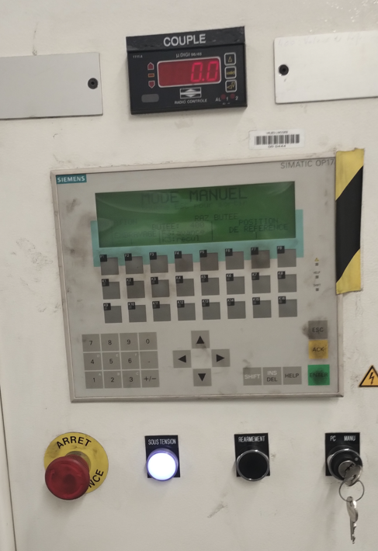

Button | Label | Function | Mode
Red mushroom head | E-STOP (ARRET) | Emergency stop — twist to release | All modes
White illuminated | RESET | Reset safety relay after E-stop or fault | All modes
Key switch | C | Select Auto / Manual mode — key held by Operator 2 | All modes
Push button | F1 | Manually rotate clutch (hold-to-run) | Manual only
Push button | F2 | Engage / disengage clutch | Manual only
Push button | F3 | Clutch bed forward | Manual only
Push button | K3 | Clutch bed reverse | Manual only
Push button | F5 | Position reset to zero | Manual only
Push button | F7 | Position Auto Set | Manual only
Digital display | Clamp Torque | Shows clamping force in DaN — target 450 to 500 DaN | All modes

2.1 Indicator lamp status
Lamp | State | Meaning / Action
Green | ON steady | Control circuit healthy — no action needed
Green | OFF | Control circuit off — check power, isolator, Control ON button
Yellow | ON steady | Test running in auto mode — normal
Yellow | Flashing | Fault or warning — check MORPHEE display
Red | ON steady | E-stop active or safety relay fault — identify cause, reset per Section 5
Red | Flashing | VFD trip or motor fault — refer Section 7 troubleshooting

3 Pre-Start Verification Checklist
Complete before every shift and every test run. Do not start the machine if any item cannot be confirmed.

Item | Check | OK? | Init.
A1 | Main panel SSB-02 — LE Bench supply breaker ON | ☐
A2 | Machine rotary isolator on control panel — ON | ☐
A3 | Green power indicator lamp illuminated (24V DC healthy) | ☐
A4 | No MCB or MPCB in control panel in tripped position | ☐
B1 | Compressed air supply valve open | ☐
B2 | Air pressure regulator reading 4 to 6 bar | ☐
B3 | Pneumatic filter bowl — no water or contamination | ☐
C1 | Dust collection exhaust motor starter switched ON | ☐
C2 | Airflow felt at exhaust outlet | ☐
C3 | Air filter — clean, not overdue for replacement | ☐
D1 | All fixed guards (G001, G002, G003) in position | ☐
D2 | All three machine doors closed and interlock solenoids engaged | ☐
D3 | All three E-stop buttons tested — red lamp lights, twist to release | ☐
D4 | Pilz PNOZ X3 reset successful — all channel LEDs illuminated | ☐
D5 | No persons inside machine enclosure or hazard zone | ☐
E1 | MORPHEE running — no startup error, all channels reading | ☐
E2 | Test program file selected in MORPHEE | ☐
F1 | All required PPE available and serviceable | ☐
F2 | Machine area clear — no obstructions in 1 m zone | ☐

DO NOT START if any of these conditions exist:
- Any E-stop button is latched and cannot be released by twisting
- Any door interlock is not engaging
- Air pressure outside 4 to 6 bar range
- Any MCB / MPCB in the tripped position
- MORPHEE displaying a fault or error
- Any guard missing, damaged, or not in position
- Visible smoke, burning smell, oil leak, or other abnormal condition

Pre-start sign-off
Date | Shift | Operator name | Signature

4 Operating Cycle — Step-by-Step Summary
All clutch loading, displacement setting, and manual mode door access must be performed by Operator 2 only.

4.1 Machine starting

4.2 Cover plate preparation (at oven — before loading)
⚠ WARNING: Oven operates at 300°C. Use heat-resistant gloves. Allow components to cool before fitting thermocouple.

- Bolt flywheel (17 mm) + sim washer (7.7 mm) + cover plate using M8 bolts.
- Place assembly in oven at 300°C for 1.5 hours.
- Drill 4.8 mm thermocouple holes: centre surface + outer punched rivet of cover plate.
- Remove from oven using heat-resistant gloves. Allow to cool.
- Fit thermocouple into both drilled hole locations.

4.3 Clutch assembly loading (Manual mode)
- Confirm mode key switch (C) is in Manual. Operator 2 holds key.
- Open machine door. Confirm interlock releases.
- Place friction disc on drive shaft — align using M8 Aline key bolt and spline.
- Fit flywheel to adapter using M5 bolt.
- Fit and tighten cover plate using M8 bolts (cross-pattern).
- Rotate lead screw wheel — move bed forward until drive shaft connected.
- Connect thermocouple plug.
- Tighten M10 slinckey fixing bolt to secure bed.
- Close machine door. Confirm interlock engages.

4.4 Clutch displacement setting
Target: 450 to 500 DaN on Clamp Torque display.

- Confirm mode key (C) in Manual.
- Press F2 — disengage.
- Press and hold F1 — rotate disc.
- Press F2 — engage. Check clamp torque display.
- Below 450 DaN → press F3 (forward). Repeat from Step 2.
- 450 to 500 DaN → displacement correct. Go to Step 5.
- Above 500 DaN → press K3 (reverse). Repeat from Step 2.
- Press F5 — Position Reset to zero.
- Press K3 — move to -400.
- Press F5 — second Position Reset.
- Press F7 — Position Auto Set.
- Turn mode key (C) to Auto. Machine ready for test launch.

4.5 Test launch
- In MORPHEE, select the required test program file.
- Confirm mode key (C) in Auto.
- Confirm all three doors closed and locked.
- Press Validation button in MORPHEE. Confirm all conditions met.
- Press Start. Test begins — MORPHEE records torque, temperature, RPM.

4.6 Test monitoring — each shift
- Check MORPHEE — torque, temperature, RPM within range, no alarms.
- Check dust collection exhaust is running — airflow felt at outlet.
- Check air pressure — 4 to 6 bar.
- Record cycle count in machine log.
- Confirm no one has entered the 1 m machine clearance zone.

4.7 Inspection at 6,000 cycles
⚠ WARNING: Pause test and wait for all motion to stop. Wait for door guard locking unit to release automatically before opening any door.
⚠ CAUTION: High internal temperatures after testing. Wear heat-resistant gloves. Do not touch clutch components with bare hands.

- Pause or stop test in MORPHEE.
- Wait for all rotating parts to stop completely.
- Wait for door guard locking unit to release automatically.
- Open door. Clean friction disc with compressed air (wear FFP2 respirator).
- Measure and record wear depth.
- Assess and record surface bedding percentage — both faces.
- If within acceptance criteria: reassemble (Section 4.3, Steps 3–9) and relaunch.
- If worn beyond acceptance: remove clutch (Section 4.8), hand scrapped components to EHS.

4.8 Clutch removal
- Stop test in MORPHEE. Confirm all motion stopped.
- Wait for door locking unit to release. Open door.
- Remove bed fixing bolt.
- Rotate lead screw wheel — move bed in reverse until drive shaft disconnected.
- Disconnect thermocouple plug.
- Remove friction disc, cover plate, and flywheel.
- Send components to quality inspection station.

4.9 Machine shutdown
- Stop or pause test in MORPHEE. Wait for motion to stop.
- Save MORPHEE data files. Close MORPHEE.
- Mode key (C) to Manual. Remove key. Store securely.
- Turn rotary isolator to OFF.
- Switch OFF LE Bench supply at SSB-02.
- Switch OFF dust collection exhaust starter.
- Sign off machine log — record cycle count, test status, observations.

5 Safety Rules and PPE

5.1 Non-negotiable safety rules
- Only authorised, trained personnel may operate or maintain this machine.
- Never enter the 1 m clearance zone while a test is running in automatic mode.
- Never bypass, defeat, or remove any guard, interlock, or safety device.
- Never operate the machine with a known fault.
- Operator 2 must hold the mode key at all times during manual mode.
- Visitors must not enter the machine area without EHS escort.

5.2 PPE requirements
PPE | When required | Who
Safety glasses | All times in machine area | All personnel — mandatory
Hearing protection (ear plugs / muffs) | All test runs | All personnel in area
FFP2 respirator | Friction disc handling, 6,000 cycle inspection, compressed air cleaning | Operator 2
Heat-resistant gloves (min. 300°C) | Oven handling and clutch removal after testing | Operator 2
Safety shoes (steel-toed) | All times in machine area | All personnel

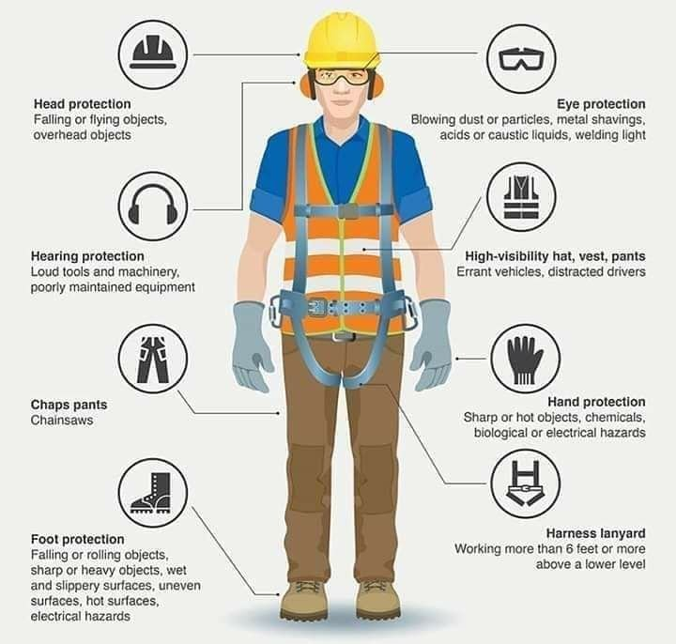

5.3 Emergency stop procedure
E-stop button locations: (1) Operator panel — front of machine. (2) Left side of machine enclosure. (3) Cabin workstation area.

- Press nearest E-stop immediately. Shout warning to others.
- Do not touch a person in contact with the machine — call for help.
- Call EHS Lead and maintenance person (Section 8 — Emergency Contacts).
- Do not restart until cause is investigated and resolved.

To reset after E-stop:
- Confirm area is safe and all persons are clear.
- Identify and resolve the cause.
- Twist all three E-stop buttons clockwise until they pop out.
- Press RESET. Press Control ON.
- Record the E-stop event in the machine log before restarting.



5.4 LOTO — Lockout / Tagout Procedure
LOTO is mandatory before any maintenance activity, guard removal, or physical access inside the machine or control panel. Each person working on the machine must apply their own personal padlock — only that person may remove it.



Energy isolation points
Energy source | Isolation point | Method
Electrical — machine supply | Rotary isolator on machine control panel | Turn to OFF position — padlock + LOTO tag
Electrical — mains supply | SSB-02 panel — LE Bench supply breaker | Switch OFF — padlock + LOTO tag
Pneumatic — compressed air | Pneumatic LOTO valve on supply line to machine | Turn valve to CLOSED — operate exhaust valve to bleed all residual pressure — confirm zero bar on gauge — padlock + LOTO tag

⚠ WARNING: Every person working on the machine must apply their own personal padlock to each isolation point. A padlock may only be removed by the person who applied it. Do not remove another person's padlock under any circumstances.

Tag-out sequence (before starting work)
- Inform the shift supervisor and EHS Lead that the machine is being isolated for maintenance.
- Stop the machine using the normal shutdown procedure (Section 4.9) if it is running.
- At the machine control panel — turn the rotary isolator to OFF. Apply personal padlock and LOTO tag.
- At SSB-02 panel — switch OFF the LE Bench supply breaker. Apply personal padlock and LOTO tag.
- At the pneumatic LOTO valve — turn to CLOSED. Operate the exhaust valve to bleed all residual air pressure. Confirm the pressure gauge reads zero.
- Apply personal padlock and LOTO tag to the pneumatic LOTO valve.
- LOTO tag must state: your name, date and time, reason for isolation, and your contact number.
- Attempt to press Control ON — confirm the machine does NOT energise. Zero-energy state confirmed.
- Record the tag-out in the machine log before beginning any work.

Tag-in sequence (after work is complete)
- Confirm all maintenance work is complete. All tools removed from machine.
- Confirm all guards and covers have been replaced and secured.
- Warn all persons in the area that energy is about to be restored.
- Remove pneumatic LOTO valve padlock and tag (by the person who applied it only). Open the pneumatic valve. Confirm pressure builds to 4 to 6 bar.
- Remove SSB-02 breaker padlock and tag. Switch ON the LE Bench supply breaker.
- Remove rotary isolator padlock and tag. Turn rotary isolator to ON.
- Complete the full pre-start verification checklist (Section 3) before returning the machine to service.
- Record the tag-in completion in the machine log — include your name and the time.

5.5 Thermal hazards
- Internal clutch assembly temperatures can reach 300°C during sustained test runs.
- Wear heat-resistant gloves when handling components from the oven or after test completion.
- Wait for the door guard locking unit to release automatically — this confirms it is safe to open the door.
- Do not place flammable materials within 1 m of the machine during testing.



5.6 Dust hazard
⚠ CAUTION: Friction disc dust contains glass fibre and metal. This is a respiratory hazard. Always wear FFP2 respirator when handling friction discs or cleaning with compressed air.

- Dust collection exhaust must run at all times during testing.
- Dispose of used filters and scrap friction discs through the Valeo EHS team — not general waste.
- Wash hands after all friction disc handling.

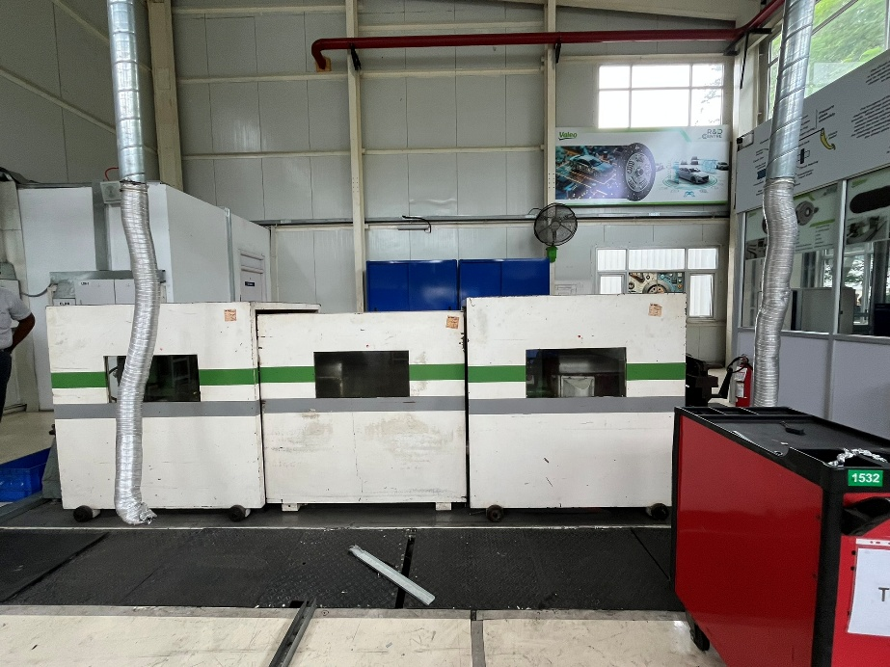

6 Alarms and Troubleshooting — Quick Reference
Fault | Symptom | Likely cause | Action
Control circuit does not energise | Green lamp off after Control ON | Isolator OFF, MCB tripped, E-stop latched, or safety relay not reset | Check isolator ON. Check all MCBs up. Release all E-stops. Press RESET then Control ON.
Safety relay not resetting | Red lamp stays ON after E-stop release and reset | E-stop not fully released, door open, or PNOZ X3 fault | Confirm all E-stops twisted out. Confirm all doors closed and locked. Check PNOZ X3 LEDs — call maintenance if not resolved.
VFD trip | Red lamp flashing, motor stops | Overcurrent, overtemp, overvoltage, or phase loss | Note VFD fault code. Allow 5 min cooling. Check motor not jammed. If persistent — call specialist.
Door interlock not engaging | Machine will not start in auto mode | Door not fully closed, or solenoid fault | Confirm door is physically closed. If solenoid still fails — call maintenance.
Air pressure fault | MORPHEE fault display, machine stops | Pressure below 4 bar or above 6 bar, valve closed, or regulator fault | Check supply valve is open. Adjust regulator to 4 to 6 bar. If cannot maintain — call maintenance.
Torque reading zero or erratic | MORPHEE shows 0 DaN or erratic torque | Load cell disconnected or calibration drift | Stop test. Check connections. Perform torque calibration check. Call maintenance if unresolved.
Temperature reading zero or max | MORPHEE temperature channel error | Thermocouple disconnected or damaged | Stop test. Check thermocouple plug is connected. Call maintenance if still incorrect.
MORPHEE will not start | Black screen or error on startup | Software or NI card communication fault | Record exact error message. Do not reinstall software. Call New Craft Technology specialist.

7 Maintenance Schedule Summary
OPEN ACTION OA-005: Maintenance intervals below are based on standard industrial practice. Valeo Friction Materials India Private Limited must formally confirm all intervals before this document is finalised.

Activity | Frequency | Who | LOTO?
Pre-start verification checklist (Section 3) | Every shift | Operator 1 or 2 | No
Air filter inspection — visual | Weekly | Operator 1 or 2 | No
Pneumatic filter bowl drain | Weekly | Operator 1 or 2 | No
General housekeeping — external clean | Weekly | Operator 1 or 2 | No
Air filter replacement | Monthly or as required | Operator 2 + Maintenance | Yes
Torque calibration check (NABL vendor) | Every 6 months | Maintenance + Calibration vendor | No
Temperature calibration check (NABL vendor) | Every 6 months | Maintenance + Calibration vendor | No
RPM calibration check (NABL vendor) | Every 6 months | Maintenance + Calibration vendor | No
Dust collection duct and fan inspection | Every 6 months | Maintenance person | Yes
Electrical cabinet inspection (specialist) | Every 6 months | New Craft Technology | Yes
Pilz PNOZ X3 full function test (specialist) | Every 12 months | New Craft Technology | Yes
Pneumatic cylinder and actuator inspection | Every 12 months | Maintenance / New Craft Technology | Yes

7.1 Air filter replacement summary
⚠ CAUTION: Complete LOTO before accessing filter housing. Used filters contain glass fibre and metal dust — dispose through Valeo EHS team.

- Complete LOTO procedure (full procedure in Operating & Safety Manual, Section 7.5).
- Open filter housing access panel.
- Remove used filter into a sealed plastic bag — do not shake or blow out.
- Insert new filter in correct orientation (check directional arrow on filter frame).
- Close and secure access panel.
- Complete LOTO tag-in. Start machine. Confirm exhaust running correctly.
- Record replacement in machine log.

7.2 Calibration summary
Parameter | Method (summary) | Acceptance criteria
Torque | 1 metre arm bar + calibration masses: 5 / 15 / 25 / 35 / 45 kg. Compare MORPHEE reading vs calculated DaN reference. | Within tolerance at all mass steps — confirm with NABL calibration vendor
Temperature | Fluke reference thermometer. Reference points: 0 / 40 / 80 / 100 / 200 / 300°C. | MORPHEE reading within ±2°C of reference thermometer at each point
RPM | Calibrated tachometer. Setpoints: 500 / 1000 / 1500 RPM. Enter manual RPM in CVM field in MORPHEE. | MORPHEE reading within ±10 RPM of tachometer at each setpoint

8 Emergency Contacts
Role | Name and contact number
EHS Lead — Valeo Friction Materials India Pvt. Ltd. | [Insert name and phone number]
R&D Deputy Manager | [Insert name and phone number]
Maintenance Person (in-house) | [Insert name and phone number]
Third-party Specialist — New Craft Technology (Job No. 1639) | [Insert name and phone number]
Plant Security | [Insert phone number]
Ambulance / Emergency services | 108 (Tamil Nadu)
Fire services | 101
Local police | 100

9 Open Actions Register — Summary
All open actions below must be formally closed by Valeo Friction Materials India Private Limited before this manual is considered complete. Refer to the full Operating & Safety Manual for complete descriptions.

OA No. | Description (summary) | Responsible party | Status
OA-001 | Machine nameplate data (serial, model, manufacturer) not available — retrofit machine. | Valeo | Open
OA-002 | Drive motor and gear motor electrical ratings not confirmed — must be verified from nameplates. | Valeo | Open
OA-003 | Busbar acrylic guard G004 — fabrication and installation not confirmed. | Valeo / New Craft Technology | Open
OA-004 | Overvoltage surge protection device — installation not confirmed. | Valeo | Open
OA-005 | Maintenance frequency intervals not formally confirmed by customer. | Valeo | Open
OA-006 | Commissioning protocol not formally documented or approved by customer. | Valeo / New Craft Technology | Open
OA-007 | Document number not assigned — confirm per Valeo document control procedure. | Valeo | Open

This quick reference was prepared alongside the full Operating & Safety Manual (Rev 00, March 2026). For complete procedures, compliance documentation, and legal requirements, always refer to the full manual.

